**BLOGING:** [**https://vigsara.blogspot.com/**](https://vigsara.blogspot.com/)

**VIGSARA CLOTHING**

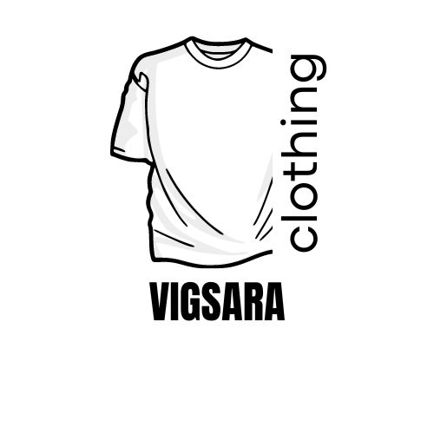

***T-SHIRTS:***

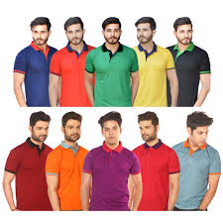

   Our t-shirts are light weight, usually knitted, pullover shirt, close-fitting and with a round neckline and short sleeves, worn as an undershirt or outer garment.

***BLACK T-SHIRTS:***

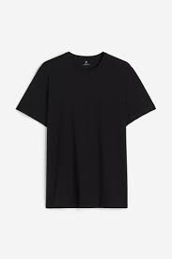

 This colour black has great power. It has all the potential to look smart and classy. Any special occasion, party or a date you can match it up with any bottom and carry yourself in a super smart way. This black t-shirts are American made design #trending.

***WHITE T-SHIRTS:***

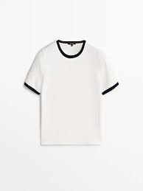

 White shirts are so simple yet by virtue of its simplicity so hard to get right. What makes the perfect white tee? Fabric, fit and detailing of course but it’s in the minutiae of the details where we find the joy. In short, this essential wardrobe staple converges the best of t-shirt detailing into, in our humble opinion, the best white tees on the market.